**IoT Based Smart Crop Protection System**

**For Agriculture**

**Authors:** Mohit Korche , Sarthak Tokse , Shubham Shirbhate , Vaibhav Thakre , S. P. Jolhe

**Abstract:**

Agriculture is the backbone of the economy but because of animal interference in agricultural lands, there will be huge loss of crops. This article provides a comprehensive review of various methods adopted by farmers to protect their crops. The article also discusses use of modern technology in agriculture. Finally, this article reviews smart crop protection system using sensors, microcontroller and gsm module.

**INTRODUCTION**

Crops in farms are many times ravaged by local animals like buffaloes, cows, goats, birds etc. This leads to huge losses for the farmer. Due to over population, it occurs a deforestation this results in shortage of food, water and shelter in forest areas. So, animal’s interference in residential areas is increasing day by day which affects human life and property causes human animal conflict but as per nature’s rule every living creature on this earth has important role in eco-system. Elephants and other animals coming in to contact with humans, impact negatively in various means such as by depredation of crops, damaging grain stores, water supplies, houses and other assets, injuring and death of humans. So here we propose automatic crop protection system from animals. This is a microcontroller-based system using PIC family microcontroller. These systems use a motion sensor to detect wild animal approaching near the field. In such a case the sensor signal the microcontroller to take action. Traditional methods used by farmers are given below.

**DESCRIPTION OF STUDY AREA**

Description of study area A systematic survey of 160 households in district was conducted to study the extent of crop raiding by wild animals. Almost all respondents (97.5%) reported crop damage by wild animals. Most crop damage was done by deer (91.1%). Farmers mostly used traditional nonlethal measures to secure their crops from wild animals.The most widely used measures were fencing (82.5%), guarding (75%), and scarecrows (71.9%). Farmers felt the need for the government to intervene- by providing permanent fencing materials (27.4%), legalizing killing (26.85%), introducing compensation schemes (18.3%) and investing in electrification of the field perimeters (17.7%).

**COMPONENTS REQUIRED**

1. **PIR SENSOR(Passive infrared sensor)**

A passive infrared sensor (PIR sensor) is an electronic device that measures infrared (IR) light radiating from objects in its field of view. Apparent motion is detected when an infrared source with one temperature, such as a human, passes in front of an infrared source with another temperature, such as a wall. PIR sensor detects a human being moving around within approximately 10m from the sensor. This is an average value, as the actual detection range is between 5m and 12m Power is usually up to 5V.

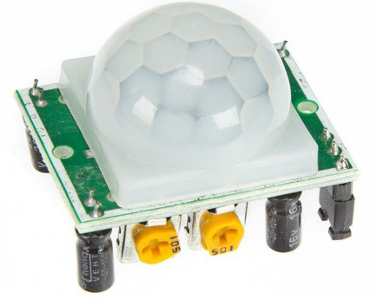

Fig.1. PIR Sensor

1. **LCD Display**

There are many display devices used by the hobbyists. LCD displays are one of the most sophisticated display devices used by them. Once you learn how to interface it, it will be the easiest and very reliable output device used by you. More, for micro controller-based project, not every time any debugger can be used. So LCD displays can be used to test the outputs. Obviously, for last possibility, you need to know how to use this stuff pretty well. Hitachi has set up a mile stone by its LCD controller IC. one of the IC s based upon the architecture introduced by Hitachi.

**3. GSM Module**

GSM stands for Global System for Mobile Communications. It is a standard set developed by the European Telecommunications Standards Institute (ETSI) to describe pro- tools for second generation (2G) digital cellular networks used by mobile phone.

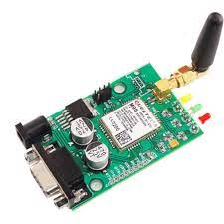

Fig.2. GSM Module

1. **Buzzer**

A buzzer is a loud noise maker. Most modern ones are civil defense or air- raid sirens, tornado sirens, or the sirens on emergency service vehicles such as ambulances, police cars and fire trucks. There are two general types, pneumatic and electronic. A buzzer or beeper is an audio Signaling device, which be mechanical, electromechanical, or piezoelectric (piezo for short). Typical uses of buzzers and beepers include alarm devices, timers, and confirmation of user input such as a mouse click or keystroke.

• Rated Voltage 6V DC

• Operating Voltage to 8V DC

• Sound Output at 10cm at 85dB

• Tone : Continuous

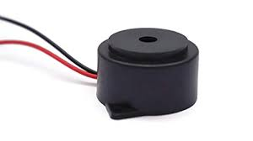

Fig.3. Buzzer

**5. Laser Diode**

A laser diode, (LD), injection laser diode (ILD), or diode laser is a semiconductor device similar to a lightemitting diode in which a diode pumped directly with electrical current can create lasing conditions at the diode's junction.[1]:3 Laser diodes can directly convert electrical energy into light. Driven by voltage, the doped p-n-transition allows for recombination of an electron with a hole. Due to the drop of the electron from a higher energy level to a lower one, radiation, in the form of an emitted photon is generated. This is spontaneous emission. Stimulated emission can be produced when the process is continued and further generate light with the same phase, coherence and wavelength. The choice of the semiconductor material determines the wavelength of the emitted beam, which in today's laser diodes range from infra-red to the UV spectrum. Laser diodes are the most common type of lasers produced, with a wide range of uses that include fiber optic communications, barcode readers, laser pointers, CD/DVD/Blu-ray disc reading/recording, laser printing, laser scanning and light beam illumination. With the use of a phosphor like that found on white LEDs, Laser diodes can be used for general illumination.

**CONCLUSION**

The problem of crop vandalization by wild animals and fire has become a major social problem in current time. It requires urgent attention as no effective solution exists till date for this problem. Thus, this project carries a great social relevance as it aims to address this problem. This project will help farmers in protecting their orchards and fields and save them from significant financial losses and will save them from the unproductive efforts that they endure for the protection their fields. This will also help them in achieving better crop yields thus leading to their economic wellbeing.

**REFERENCE**

* ArturFrankiewicz; RafałCupek.” Smart Passive Infrared Sensor - Hardware Platform
* Padmashree S. Dhake, Sumedha S. Borde, “Embedded Surveillance System Using PIR Sensor”, International Journal of Advanced Technology in Engineering and Science.